Nedging With Naughton Parish Council
will hold a

Public Meeting

TO DISCUSS THE QUIET LANES PROPOSALS

ON TUESDAY 13TH APRIL 2021

AT 19:00

VIA ZOOM APPLICATION

PLEASE CONTACT THE PARISH COUNCIL CLERK VIA EMAIL
FOR JOINING DETAILS

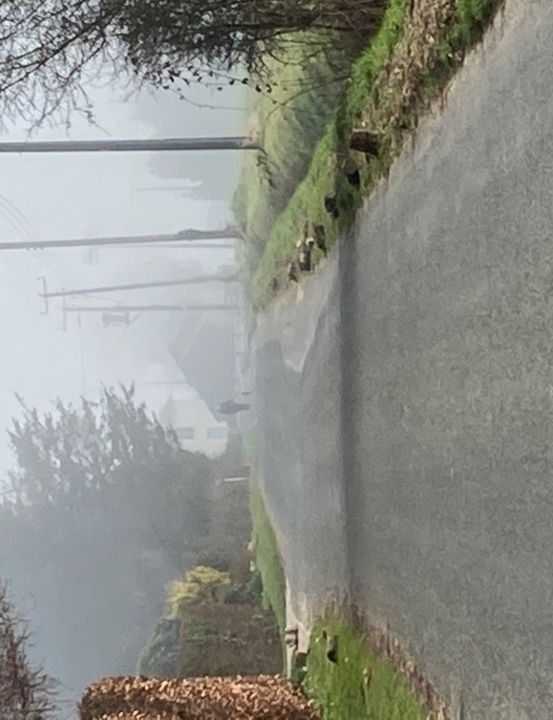
pc@nedging-naughton.suffolk.gov.uk
